Datapath
- Building a datapath
  - Datapath Stages
  - Instructions Reading
  - Registers and ALU. R-type instructions.
  - Data Memory. Load and Store instructions.
  - Brach Instructions
  - Creating a single datapath

Textbook P&H Ch.4. Datapath and Control.

The processor logically comprises two main components: datapath and control, the respective brawn and brain of the processor. The datapath performs the arithmetic operations, and control tells the datapath, memory, and I/O devices what to do according to the wishes of the instructions of the program.

- Processor (CPU): the active part of the computer that does all the work (data manipulation and decision-making)
- Datapath: portion of the processor that contains hardware necessary to perform operations required by the processor (the brawn)
- Control: portion of the processor (also in hardware) that tells the datapath what needs to be done (the brain)

Memory

Program Code Data

Input
Datapath

Central Processing Unit

Arithmetic Logic Unit
Registers (Accumulator)

Control

Unit

Clock

Output

Picture 1. The original von Neumann machine.

Building a Datapath

Datapath stages

- The whole cycle of instruction execution should be implemented in datapath.
- Problem: a single, atomic block that “executes an instruction” (performs all necessary operations beginning with fetching the instruction) would be too bulky and inefficient
- Solution: break up the process of “executing an instruction” into stages, and then connect the stages to create the whole datapath
- smaller stages are easier to design easy to optimize (change) one stage without touching the others

MIPS instructions classically take five steps:

1. Fetch instruction from memory.
2. Read registers while decoding the instruction. The regular format of MIPS instructions allows reading and decoding to occur simultaneously.
3. Execute the operation or calculate an address.
4. Access an operand in data memory.
5. Write the result into a register.

Sometimes we use mnemonics for these 5 steps.

1. IF: Instruction fetch
2. ID: Instruction decode and register file read
3. EX: Execution or address calculation
4. MEM: Data memory access
5. WB: Writeback

- Instruction fetch: The instruction is being read from memory using the address in the PC and then being placed in the decoding register. The PC address is incremented by 4 and then written back into the PC to be ready for the next clock cycle.

- Instruction decode and register file read:
  - upon fetching the instruction, we next gather data from the fields (decode all necessary instruction data)
  - first, read the opcode to determine instruction type and field lengths
  - second, read in data from all necessary registers
    - for add, read two registers
    - for addi, read one register
    - for jal, no reads necessary
  - Supplying the 16-bit immediate field, which is sign-extended to 32 bits

- Execute or address calculation:
- ALU (Arithmetic-Logic Unit)
  - the real work of most instructions is done here: arithmetic (+, -, *, /), shifting, logic (&, |), comparisons (slt)
  - what about loads and stores?
    - lw $t0, 40($t1)
    - the address we are accessing in memory = the value in $t1 PLUS the value 40
    - so we do this addition in this stage
- Memory Access
  - actually only the load and store instructions do anything during this stage; the others remain idle during this stage or skip it all together
  - since these instructions have a unique step, we need this extra stage to account for them
  - as a result of the cache system, this stage is expected to be fast
- Register Write
  - most instructions write the result of some computation into a register
  - examples: arithmetic, logical, shifts, loads, slt
  - what about stores, branches, jumps?
    - don’t write anything into a register at the end
    - these remain idle during this fifth stage or skip it all together

Instruction Reading

A reasonable way to start a datapath design is to examine the major components required to execute each class of MIPS instructions. Let’s start by looking at which datapath elements each instruction needs. When we show the datapath elements, we will also show their control signals.

- Figure 4.5a shows the first element we need: a memory unit to store the instructions of a program and supply instructions given an address.
- Figure 4.5b also shows the program counter (PC), which is a register that holds the address of the current instruction.
- Lastly, we will need an adder to increment the PC to the address of the next instruction. This adder, which is combinational, can be built from the big ALU performing simple changes on it.

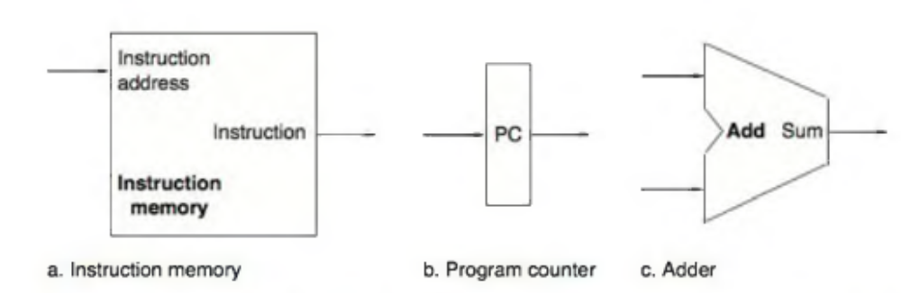

FIGURE 4.5. Two state elements are needed to store and access Instructions, and an
adder Is needed to compute the next Instruction address.

The state elements are the instruction memory and the program counter.

The instruction memory need only provide read access because the datapath does not write instructions.
Since the instruction memory only reads, we treat it as combinational logic: the output at any time reflects the contents of the location specified by the address input, and no read control signal is needed. (We will need to write the instruction memory when we load the program; this is not hard to add, and we ignore it for simplicity.)

The program counter is a 32-bit register that is written at the end of every clock cycle and thus does not need a write control signal.

The adder is an ALU wired to always add its two 32-bit inputs and place the sum on its output.
To execute any instruction, we must start by fetching the instruction from memory. To prepare for executing the next instruction, we must also increment the program counter so that it points at the next instruction, 4 bytes later. Figure 4.6 shows how to combine the three elements from Figure 4.5 to form a datapath that fetches instructions and increments the PC to obtain the address of the next sequential instruction.
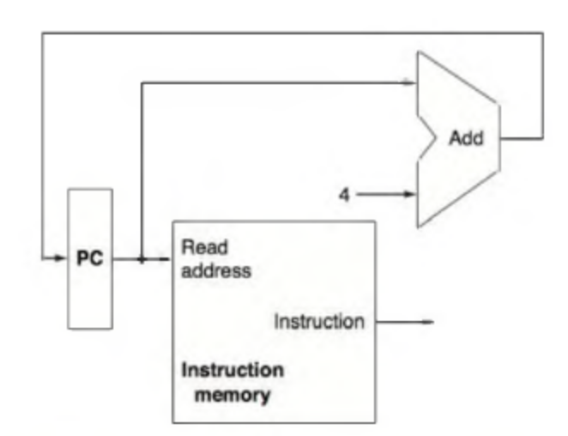  FIGURE 4.6. A portion of the datapath used for fetching instructions and incrementing the program counter. The fetched instruction is used by other parts of the datapath. | 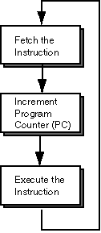

Registers and ALU. R-type instructions.

Now let’s consider the R-format instructions. They all read two registers, perform an ALU operation on the contents of the registers, and write the result to a register. We call these instructions either R-type instructions or arithmetic-logic instructions (since they perform arithmetic or logic operations). This instruction class includes add, sub, AND, OR, and slt.

The processor’s 32 general-purpose registers are stored in a structure called a register file. A register file is a collection of registers in which any register can be read or written by specifying the number of the register in the file. The register file contains the register state of the computer.

In addition, we will need an ALU to operate on the values read from the registers.

R-format instructions have three register operands, so we will need to read two data words from the register file and write one data word into the register file for each instruction. For each data word to be read from the registers, we need an input to the register file that specifies the register number to be read and an output from the register file that will carry the value that has been read from the registers.

To write a data word, we will need two inputs: one to specify the register number to be written and one to supply the data to be written into the register. The register file always outputs the contents of whatever register numbers are on the Read register inputs.

Writes, however, are controlled by the write control signal, which must be asserted for a write to occur at the clock edge. Figure 4.7a shows the result; we need a total of four inputs (three for register numbers and one for data) and two outputs (both for data). The register number inputs are 5 bits wide to specify one of 32 registers (32 = 2⁵), whereas the data input and two data output buses are each 32 bits wide.

Figure 4.7b shows the ALU, which takes two 32-bit inputs and produces a 32-bit result, as well as a 1-bit signal if the result is 0.

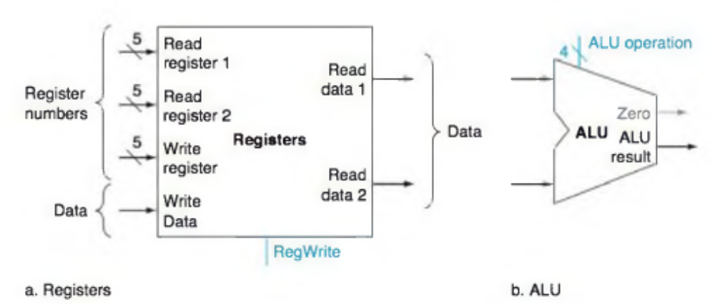

FIGURE 4.7 The two elements needed to implement R-format ALU operations are the register file and the ALU.

The register file contains all the registers and has two read ports and one write port.
The register file always outputs the contents of the registers corresponding to the Read register inputs on the outputs; no other control inputs are needed.

In contrast, a register write must be explicitly indicated by asserting the write control signal.

Remember that writes are edge-triggered, so that all the write inputs (i.e., the value to be written, the register number, and the write control signal) must be valid at the clock edge. Since writes to the register file are edge-triggered, our design can legally read and write the same register within a clock cycle:
The read will get the value written in an earlier clock cycle, while the value written will be available to a read in a subsequent clock cycle.

The inputs carrying the register number to the register file are all 5 bits wide, whereas the lines carrying data values are 32 bits wide.

The operation to be performed by the ALU is controlled with the ALU operation signal, which will be 4 bits wide. We will use the Zero detection output of the ALU shortly to implement branches.

The overflow output will not be needed yet.

The datapath for R-type instructions.
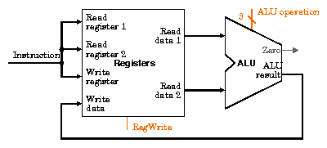

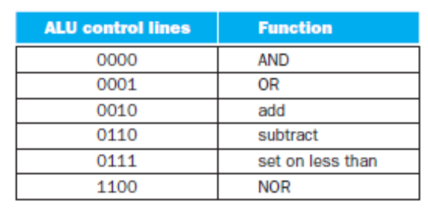

Data Memory. Load and Store instructions.

Next, consider the MIPS load word and store word instructions. These instructions compute a memory address by adding the base register to the 16-bit signed offset field contained in the instruction.
If the instruction is a store, the value to be stored must also be read from the register file.
If the instruction is a load, the value read from memory must be written into the register file in the specified register.
Thus, we will need both the register file and the ALU from Figure 4.7.

In addition, we will need a unit to sign-extend the 16-bit offset field in the instruction to a 32-bit signed value, and a data memory unit to read from or write to. The data memory must be written on store instructions; hence, data memory has read and write control signals, an address input, and an input for the data to be written into memory. Figure 4.8 shows these two elements.
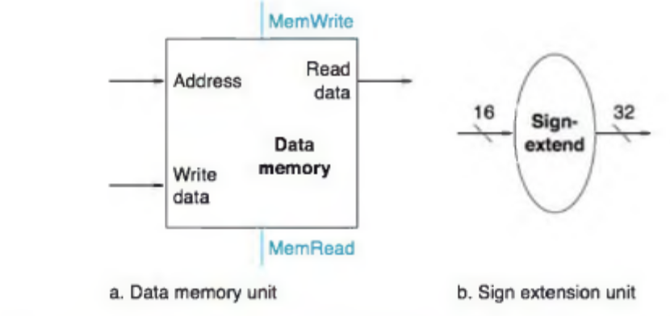
FIGURE 4.8 The two units needed to implement loads and stores, in addition to the register file and ALU of Figure 4.7, are the data memory unit and the sign extension unit.
The memory unit is a state element with inputs for the address and the write data, and a single output for the read result. There are separate read and write controls, although only one of these may be asserted on any given clock.
The sign extension unit has a 16-bit input that is sign-extended into a 32-bit result appearing on the output. Standard memory chips actually have a write enable signal that is used for writes.

The datapath for a load or store that does a register access, followed by a memory address calculation, then a read or write from memory, and a write into the register file if the instruction is a load.

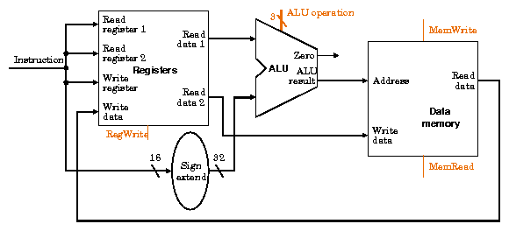

Branch instructions.

The beq instruction has three operands, two registers that are compared for equality, and a 16-bit offset used to compute the branch target address relative to the branch instruction address.
Its form is beq $ t1 ,$ t2 ,offset .
To implement this instruction, we must compute the branch target address by adding the sign-extended offset field of the instruction to the PC. There are two details in the definition of branch instructions to which we must pay attention:

- The instruction set architecture specifies that the base for the branch address calculation is the address of the instruction following the branch. Since we compute PC + 4 (the address of the next instruction) in the instruction fetch datapath, it is easy to use this value as the base for computing the branch target address.
- The architecture also states that the offset field is shifted left 2 bits so that it is a word offset; this shift increases the effective range of the offset field by a factor of 4.
  - To deal with the latter complication, we will need to shift the offset field by 2.

As well as computing the branch target address, we must also determine whether the next instruction is the instruction that follows sequentially or the instruction at the branch target address. When the condition is true (i.e., the operands are equal), the branch target address becomes the new PC, and we say that the branch is taken. If the operands are not equal, the incremented PC should replace the current PC (just as for any other normal instruction); in this case, we say that the branch is not taken.

Thus, the branch datapath must do two operations: compute the branch target address and compare the register contents. (Branches also affect the instruction fetch portion of the datapath, as we will deal with shortly.) Figure 4.9 shows the structure of the datapath segment that handles branches. To compute the branch target address, the branch datapath includes a sign extension unit, from Figure 4.8 and an adder. To perform the compare, we need to use the register file shown in Figure 4.7a to supply the two register operands (although we will not need to write into the register file). In addition, the comparison can be done using the ALU. Since that ALU provides an output signal that indicates whether the result was 0, we can send the two register operands to the ALU with the control set to do a subtract. If the Zero signal out of the ALU unit is asserted, we know that the two values are equal. Although the Zero output always signals if the result is 0, we will be using it only to implement the equal test of branches.

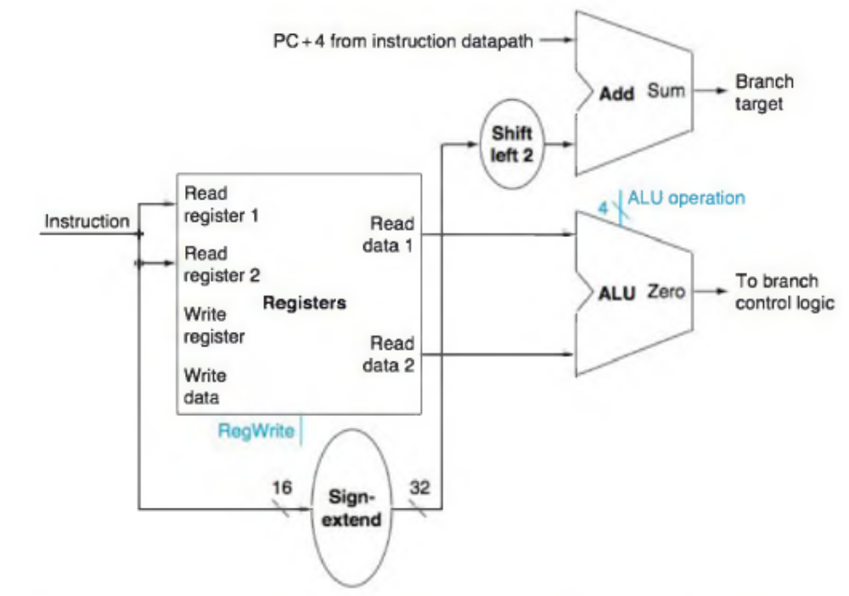
FIGURE 4.9 The datapath for a branch uses the ALU to evaluate the branch condition and a separate adder to compute the branch target as the sum of the incremented PC and the sign-extended, lower 16 bits of the Instruction (the branch displacement), shifted left 2 bits.
The unit labeled Shift left 2 is simply a routing of the signals between input and output that adds 00 to the low-order end of the sign-extended offset field; no actual shift hardware is needed, since
the amount of the “shift” is constant. Since we know that the offset was sign-extended from 16 bits, the shift will throw away only “sign bits.” Control logic is used to decide whether the incremented PC or branch target should replace the PC, based on the Zero output of the ALU.

Creating a Single Datapath

Now that we have examined the datapath components needed for the individual instruction classes, we can combine them into a single datapath and add the control to complete the implementation. This simplest datapath will attempt to execute all instructions in one clock cycle.

This means that no datapath resource can be used more than once per instruction, so any element needed more than once must be duplicated.

We therefore need a memory for instructions separate from one for data. Although some of the functional units will need to be duplicated, many of the elements can be shared by different instruction flows.

To share a datapath element between two different instruction classes, we may need to allow multiple connections to the input of an element, using a multiplexor and control signal to select among the multiple inputs.

Building a Datapath
The operations of arithmetic-logical (or R-type) instructions and the memory
instructions datapath are quite similar. The key differences are the following:
- The arithmetic-logical instructions use the ALU, with the inputs coming from the two registers. The memory instructions can also use the ALU to do the address calculation, although the second input is the sign extended 16-bit offset field from the instruction.
- The value stored into a destination register comes from the ALU (for an R-type instruction) or the memory (for a load).
Example:
Show how to build a datapath for the operational portion of the memory reference and arithmetic-logical instructions that uses a single register file and a single ALU to handle both types of instructions, adding any necessary multiplexors.

To create a datapath with only a single register file and a single ALU, we must support two different sources for the second ALU input, as well as two different sources for the data stored into the register file. Thus, one multiplexor is placed at the ALU input and another at the data input to the register file.

When 2 or more outputs we need to connect with one input then we cannot do it simply connecting the wires each to other.
We need a special device called Multiplexer. The Multiplexer has a control input and data inputs.
Depended on the Control input value (true or false) only one of the data inputs of Multiplexer passes to the output while the other input is blocked.

Figure 4.10 shows the operational portion of the combined datapath.

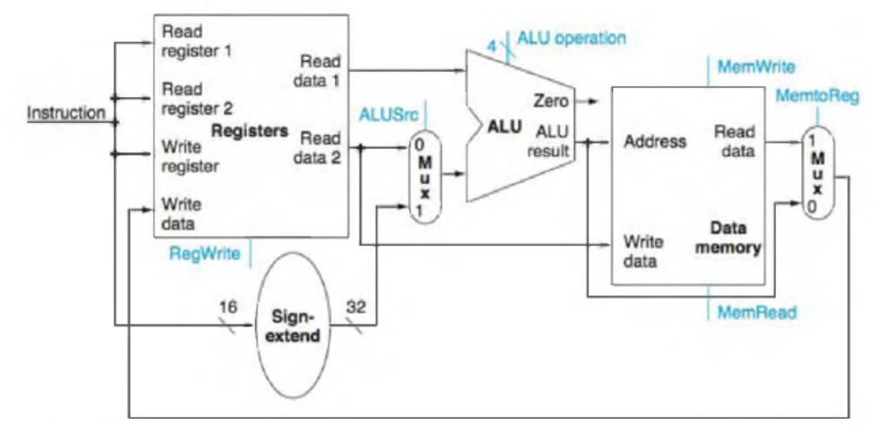

FIGURE 4.10 The datapath for the memory instructions and the R-type Instructions. This example shows how a single datapath can be assembled from the pieces in Figures 4.7 and 4.8 by adding multiplexors. Two multiplexors are needed, as described in the example.

Now we can combine all the pieces to make a simple datapath for the MIPS architecture by adding the datapath for instruction fetch (Figure 4.6), the datapath from R-type and memory instructions (Figure 4.10), and the datapath for branches (Figure 4.9). Figure 4.11 shows the datapath we obtain by composing the separate pieces. The branch instruction uses the main ALU for comparison of the register operands, so we must keep the adder from Figure 4.9 for computing the branch target address. An additional multiplexor is required to select either the sequentially following instruction address (PC + 4) or the branch target address to be written into the PC.

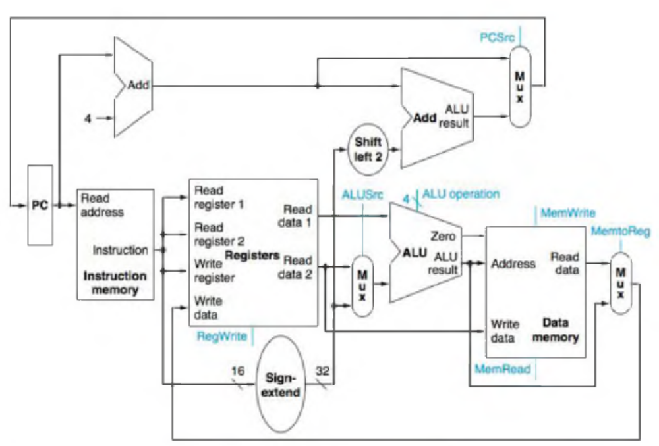

FIGURE 4.11 The simple datapath for the MIPS architecture combines the elements required by different Instruction classes.
The components come from Figures 4.6, 4.9, and 4.10. This datapath can execute the basic instructions (load-store word, ALU operations, and branches) in a single clock cycle. An additional multiplexor is needed to integrate branches.

Why a Single-Cycle Implementation Is Not Used Today

Although the single-cycle design will work correctly, it would not be used in modern designs because it is inefficient. To see why this is so, notice that the clock cycle must have the same length for every instruction in this single-cycle design.
Of course, the clock cycle is determined by the longest possible path in the processor. This path is almost certainly a load instruction, which uses five functional units in series: the instruction memory, the register file, the ALU, the data memory, and the register file.
The overall performance of a single-cycle implementation is likely to be poor, since the clock cycle is too long.

In next section, we’ll look at another implementation technique, called pipelining, that uses a datapath very similar to the single-cycle datapath but is much more efficient by having a much higher throughput. Pipelining improves efficiency by executing multiple instructions simultaneously.

A Multicycle Implementation

In an earlier example, we broke each instruction into a series of steps corresponding to the functional unit operations that were needed. We can use these steps to create a multicycle implementation. In a multicycle implementation, each step in the execution will take 1 clock cycle.

The multicycle implementation allows a functional unit to be used more than once per instruction, as long as it is used on different clock cycles. This sharing can help reduce the amount of hardware required. The ability to allow instructions to take different numbers of clock cycles and the ability to share functional units within the execution of a single instruction are the major advantages of a multicycle design. Figure 5.25 shows the abstract version of the multicycle datapath. If we compare Figure 5.25 to the datapath for the single-cycle version in Figure 4.11, we can see the following differences:

- A single memory unit is used for both instructions and data.
- There is a single ALU, rather than an ALU and two adders.
- One or more registers are added after every major functional unit to hold the output of that unit until the value is used in a subsequent clock cycle.

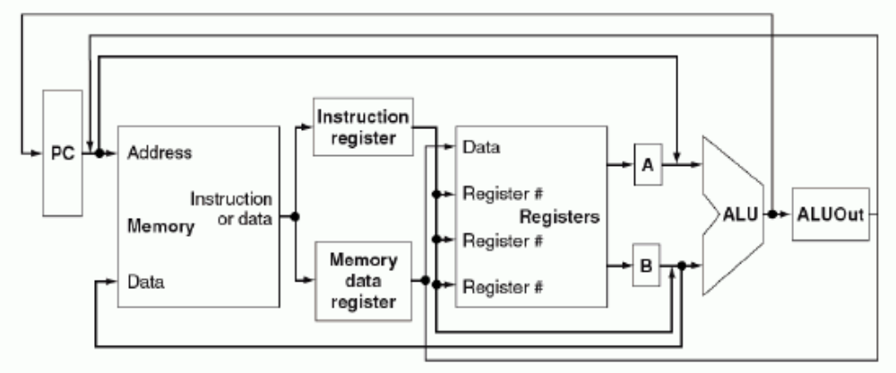

FIGURE 5.25 The high-level view of the multicycle datapath. This picture shows the key elements of the datapath: a shared memory unit, a single ALU shared among instructions, and the connections among these shared units.
The use of shared functional units requires the addition or widening of multiplexors as well as new temporary registers that hold data between clock circles of the same instruction. The additional registers are the Instruction register (IR), the Memory data register (MDR), A, B, and ALUOut.

- The Instruction register (IR) and the Memory data register (MDR) are added to save the output of the memory for an instruction read and a data read, respectively. Two separate registers are used, since, as will be clear shortly, both values are needed during the same clock cycle.
- The A and B registers are used to hold the register operand values read from the register file.
- The ALUOut register holds the output of the ALU.

At the end of a clock cycle, all data that is used in subsequent clock cycles must be stored in a state element. Data used by subsequent instructions in a later clock cycle is stored into one of the programmer-visible state elements: the register file, the PC, or the memory. In contrast, data used by the same instruction in a later cycle must be stored into one of these additional registers.

Tradeoff between Single Cycle and Multiple Cycle CPUs.

Single cycle CPU:

- A single cycle cpu executes each instruction in one cycle. in other words, one cycle is needed to execute any instruction. in other words, our cpi is 1.

- each cycle requires some constant amount of time. this means we will spend the same amount of time to execute every instruction [one cycle], regardless of how complex our instructions may be. to ensure that our processor operates correctly, our slowest instruction must be able to complete execution correctly in one clock tick.

- this is the big disadvantage of single cycle cpu's: the machine must operate at the speed of the slowest instruction.
- the big advantage of single cycle cpu's is that they are easy to implement.

Multiple cycle CPU:

- as its name implies, the multiple cycle cpu requires multiple cycles to execute a single instruction. this means that our cpi will be greater than 1.

- the big advantage of the multi-cycle design is that we can use more or less cycles to execute each instruction, depending on the complexity of the instruction.
  - for example, we can take five cycles to execute a load instruction,
  - but we can take just three cycles to execute a branch instruction.
- the big disadvantage of the multi-cycle design is increased complexity. control is now a finite state machine - before it was just combinational logic (for single cycle).

- another important difference between the single-cycle design and the multi-cycle design is the cycle time.
  - in the single cycle processor, the cycle time was determined by the slowest instruction.
  - in the multi-cycle design, the cycle time is determined by the slowest functional unit [memory, registers, alu]. this greatly reduces our cycle time.

